Table of Contents
Missing field name 1
Missing viable selection, when saving 1

Missing field name
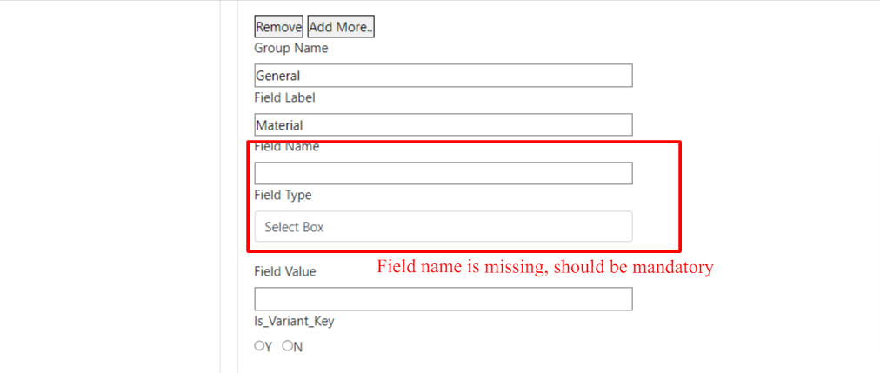
Comment: Missing validation on field name
Developer Response:

Missing viable selection, when saving

